 | FreeLancer  Hire  Website  Technical Design Document  1.0
 | Prepared By / Last Updated By | Reviewed By | Approved By
Name | Chandan Swain,  Ashish Narwal,  Bikash Gurung,  Shubham Kumar Singh,  Sagar Verma |  | Mrs. Shilpa Mahajan
Role | Team Member |  | Academy Head
Signature
Date | 04/08/2019 | 04/08/2019 | 04/08/2019

Table of Contents

1.0 Introduction 3
1.1 Purpose of this document 3
1.2 Scope 3
1.3 Intended Audience 3
1.4 Definition & Acronyms 3
2.0 Assumptions, Dependencies and Risks 4
2.1 Assumptions: 4
2.2 Dependencies: 4
3.0 Schematic Diagram 5
4.0 Use Case Realization 6
4.1.1 User Registration 6
a. Functional Requirement 6
b. UI Validations 6
c. UI Controls 6
d. UI Design 7
5.0 Database Design 8
5.1 Data Model 8
The following is a schematic view of the database design 8
5.2 Tables Structure 9
6.0 Change Log 14

Introduction

Purpose of this document
The purpose of the detail design document is to define the detailed design for all the components of Freelancer Hire Website that are specified in the Business Requirement/Use case document. All the low level components, interfaces and integrations are detailed out in this document.

Scope
This sub-section shall state the scope of this detailed design document
• Create and maintain user information.
• Create and maintain vendor information.
• Create and maintain projects.

Intended Audience
The intended audience for this document are
- Interns/project Team
- Mentors and SME’s
- Delivery assurance/excellence group

Definition & Acronyms
Acronyms | Definitions
FHW | Freelancer Hire Website

Assumptions, Dependencies and Risks

Assumptions:
- There will be no concurrent users for the application. The User profile will be maintained by the User.
- Once the user is registered the application Freelancer Hire Website will manually load the Project based on the skill.
- The Admin can register project based on required skill and update them whenever required.
- Any changes to the design mentioned in the BRD would be taken as a Change Request

Dependencies:
- Availability of database design characteristics
- Resource availability throughout each of the sprint
- User is dependent on the admin whether his proposal is accepted /rejected

Schematic Diagram
A schematic, or schematic diagram, is a representation of the elements of a system using abstract, graphic symbols rather than realistic pictures. It gives an overview of overall system
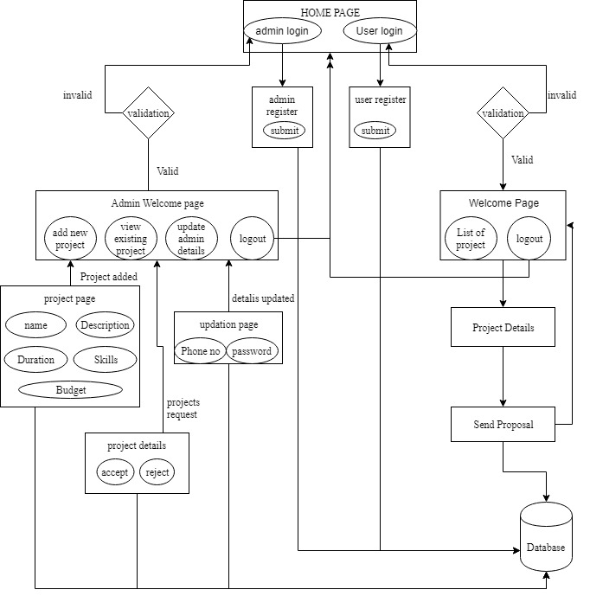
DFD for Freelancer Hire Website

Use Case Realization

User Registration

Functional Requirement
. Login Page checks the authentication of the user and based on his role, directs the user to the respective page. User will be provided with links to select the respective bill type and the will be allowed to see pending bills, can pay those bills and add new bills.

UI Validations
- User Id and Password fields are mandatory.
- Invalid User Id and / or password should not allow the user to get into the system

UI Controls
# | UI Component | Type | Name | Details
1 | Username | Text Field | username | To enter username
2 | Password | Password | password | To enter password

UI Design

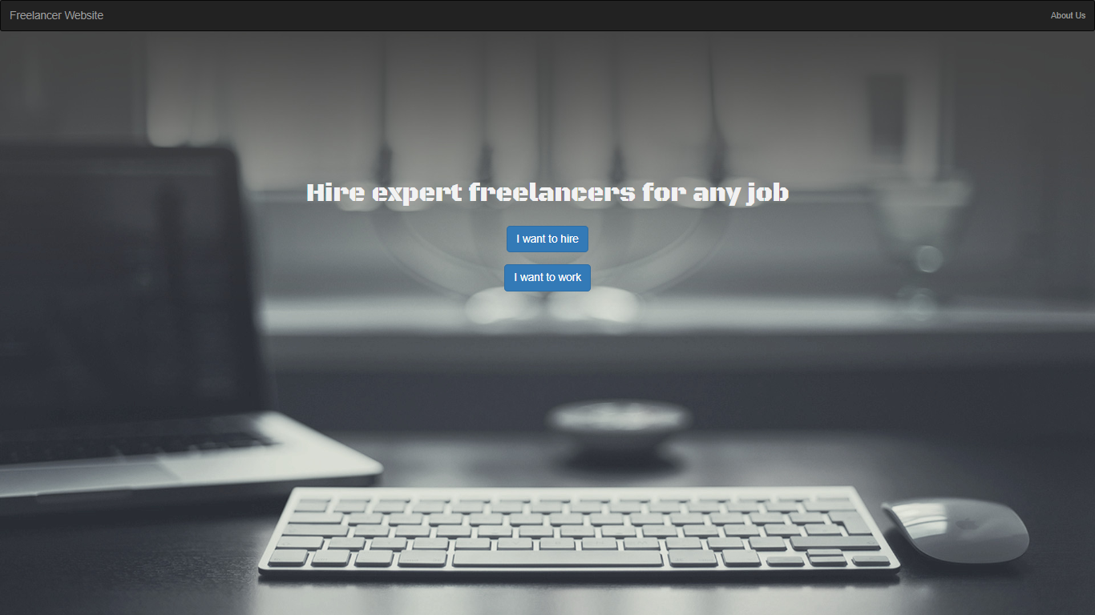

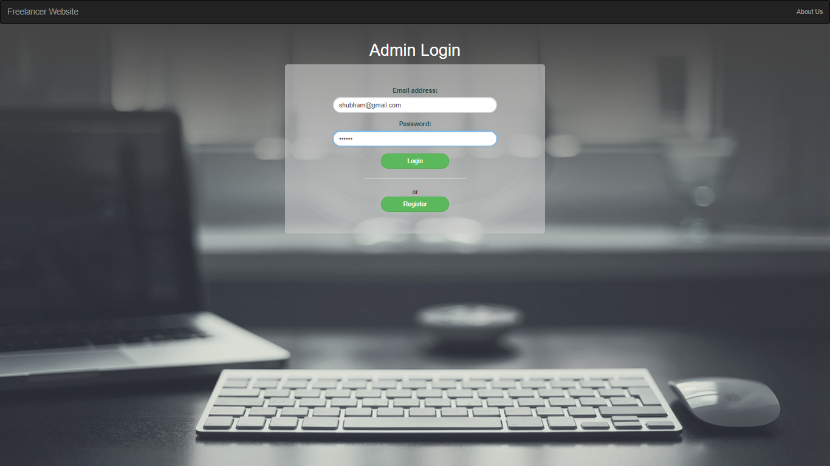

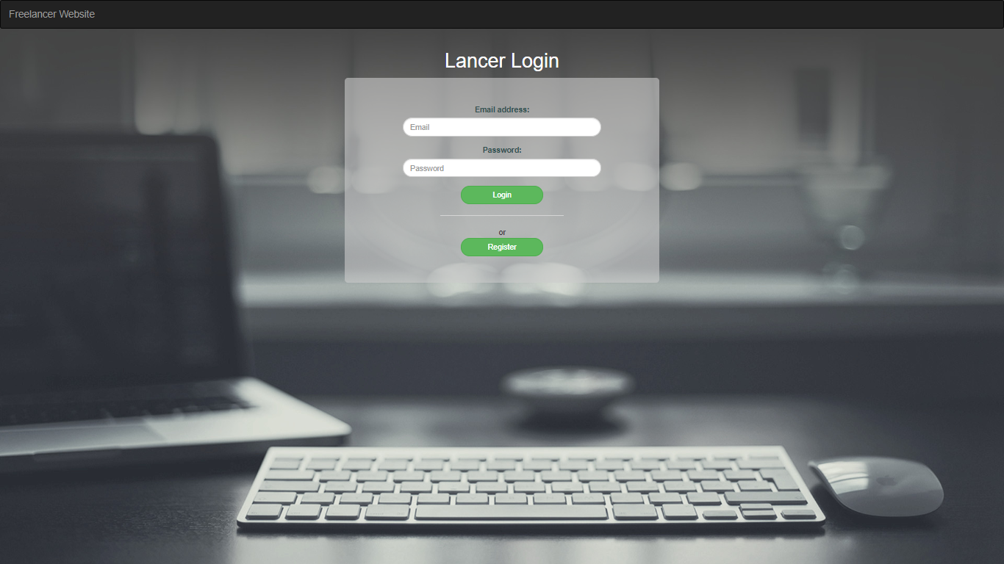

Database Design

Data Model

The following is a schematic view of the database design
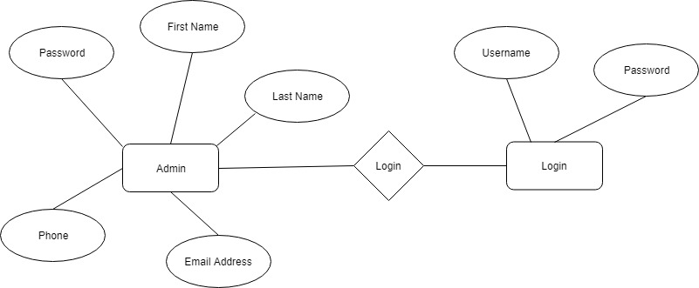

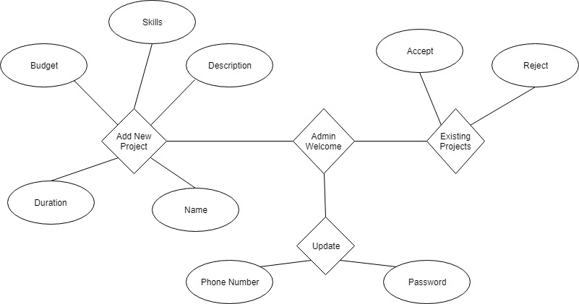

Tables Structure
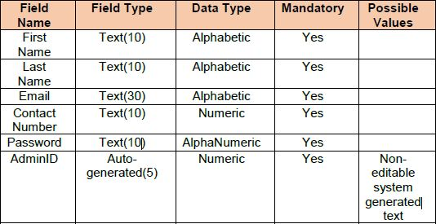
5.2.1 Admin Details

5.2.2 User Details
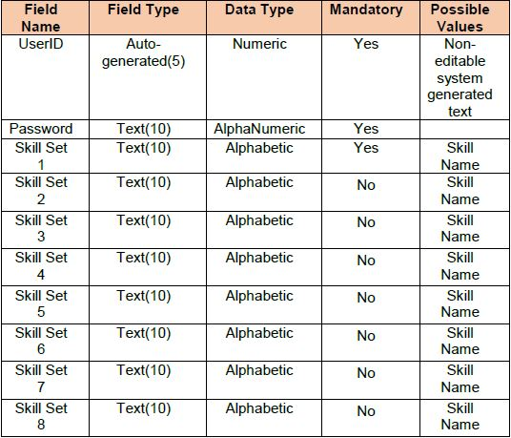

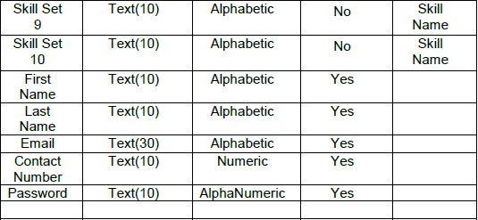

5.2.3 Project Details
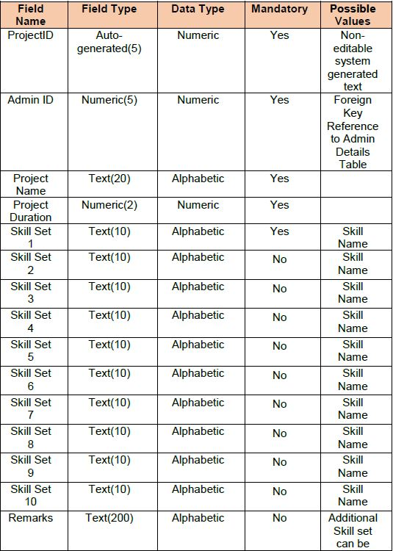

5.2.4 Skills
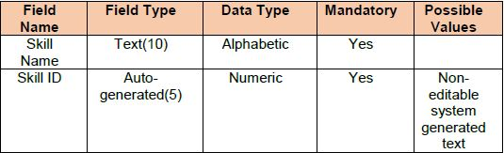

5.2.5 Project Skills
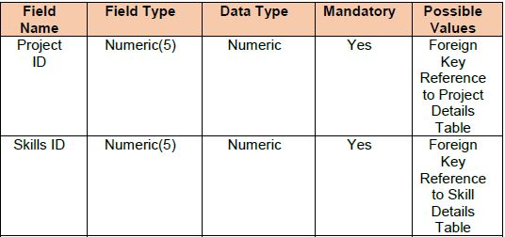

5.2.6 User skills
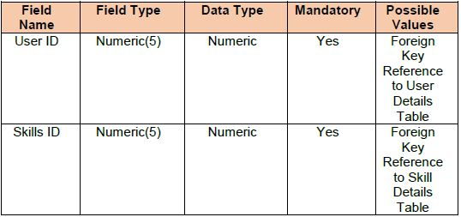

5.2.7 Proposed Project
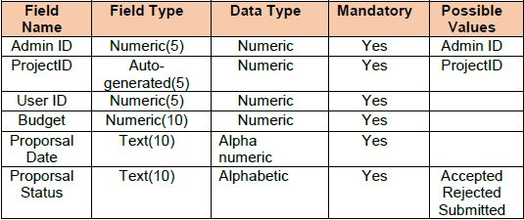

Change Log
Please note that this table needs to be maintained even if a Configuration Management tool is used.
Version Number | Changes made
V1.0 | <First version>
V1.1 | <If the change details are not explicitly documented in the table below, reference should be provided here>
V1.1 | Page no | Changed by | Effective date | Changes effected
V1.2 | <If the change details are not explicitly documented in the table below, reference should be provided here>
V1.2 | Page no | Changed by | Effective date | Changes effected

